Tushar Monga - 35214803119

**EXPERIMENT 1**

**Question 1 : Program to find sum of digits of a number**

#include<stdio.h>

void main()

{

int n;

//taking the n as input

printf("Enter the number : ");

scanf("%d",&n);

int r;

//initializing sum as 0

int sum=0;

//adding last digit each time

while(n>0) {

r=n%10;

sum+=r;

n/=10;

}

printf("Sum of the entered number : %d",sum);

}

OUTPUT

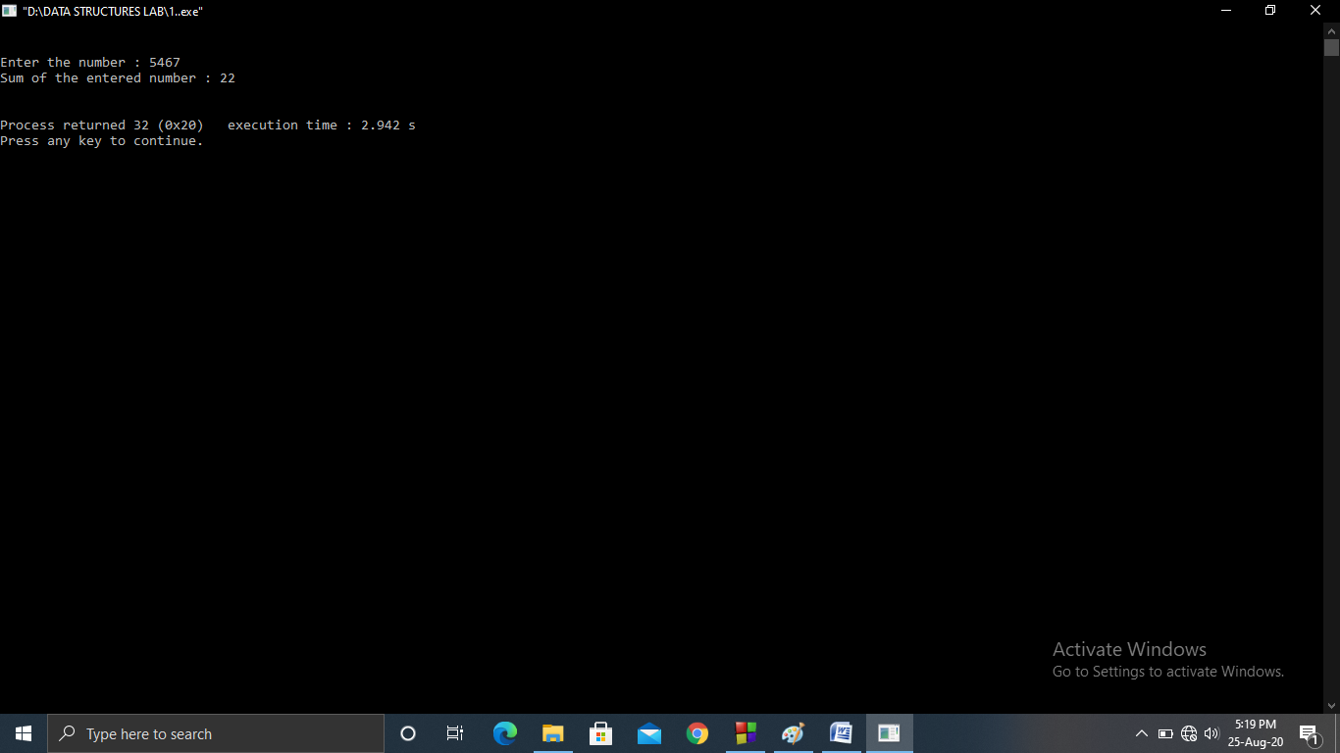

Tushar Monga - 35214803119

**Question 2 : Program to find the largest among n input numbers**

#include<stdio.h>

void main(){

int n;

int max;

printf("Enter the n : ");

scanf("%d",&n);

int temp;

scanf("%d",&temp);

//setting max as first element

max=temp;

for(int i=2;i<=n;i++) {

scanf("%d",&temp);

if(max<temp) {

max=temp;

}

}

printf("Largest among the given numbers : %d",max);

}

OUTPUT

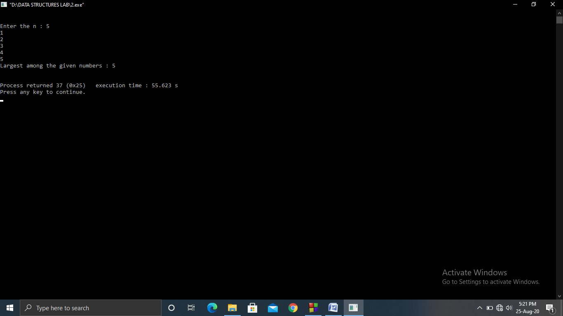

Tushar Monga - 35214803119

**Question 3 : Program to find sum of N input numbers using Array**

#include<stdio.h>

void main() {

int n;

int arr[100];

int sum=0;

printf("Enter n : ");

scanf("%d",&n);

//taking the input array and adding each element

printf("Enter the numbers : ");

for(int i=0;i<n;i++) {

scanf("%d",&arr[i]);

sum+=arr[i];

}

printf("Sum : %d",sum);

}

OUTPUT

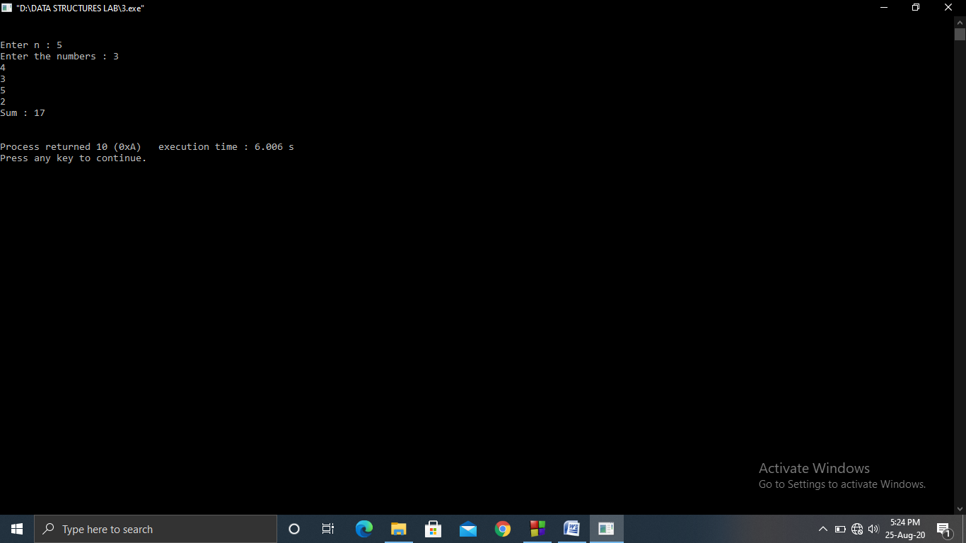

Tushar Monga - 35214803119

**Question 4 : Program to print the reverse of an Array**

#include<stdio.h>

void main() {

int a[100],b[100],n;

printf("Enter the numbers of elements : ");

scanf("%d",&n);

//taking the input array

printf("Enter the elements of array : \n");

for(int i=0;i<n;i++)

scanf("%d",&a[i]);

//filling second array in reverse order of a

for(int i=n-1,j=0;i>=0;i--,j++)

b[j]=a[i];

printf("Reversed Array : ");

for(int i=0;i<n;i++)

printf("%d ",b[i]);

}

OUTPUT

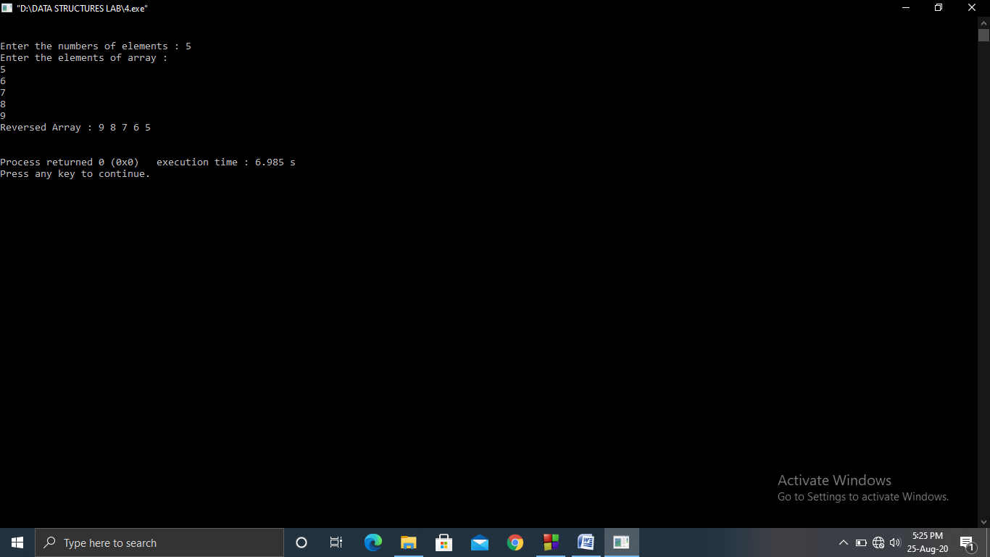

Tushar Monga - 35214803119

**Question 5 : Program to find largest and smallest element in an Array**

#include<stdio.h>

void main() {

int largest,smallest,a[100],n;

printf("Enter the numbers of elements : ");

scanf("%d",&n);

printf("Enter the elements of array : \n");

for(int i=0;i<n;i++)

scanf("%d",&a[i]);

//setting first element as largest

largest=a[0];

for(int i=0;i<n;i++){

if(largest<a[i])

largest=a[i];

}

//setting first element as smallest

smallest=a[0];

for(int i=0;i<n;i++) {

if(smallest>a[0])

smallest=a[i];

}

printf("Largest : %d\nSmallest : %d",largest,smallest);

}

OUTPUT

